Sum of First n Natural Numbers

Aim
To find the sum of the first n natural numbers using RAPTOR.

Apparatus Required
- Computer/Laptop
- RAPTOR Software
- Windows Operating System

Procedure
- Open RAPTOR.
- Input the value of n.
- Initialize the sum as 0.
- Use a loop to add numbers from 1 to n.
- Store the sum.
- Display the result.
- Execute the flowchart.
Flowchart
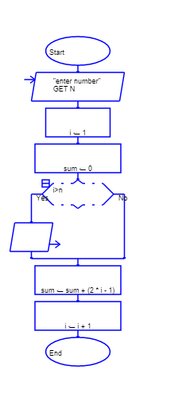
Input

Output
